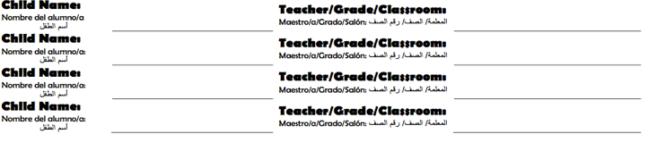
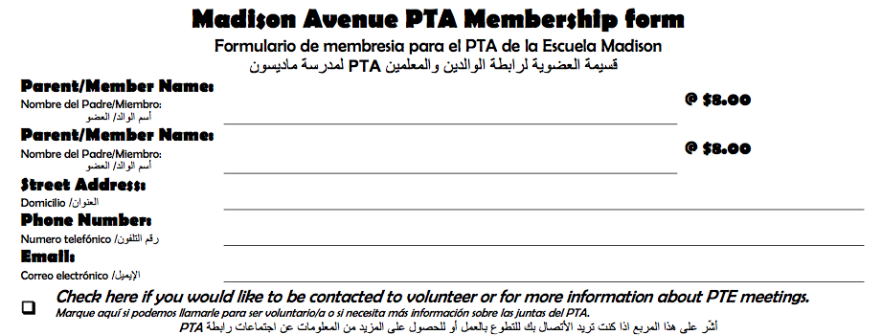
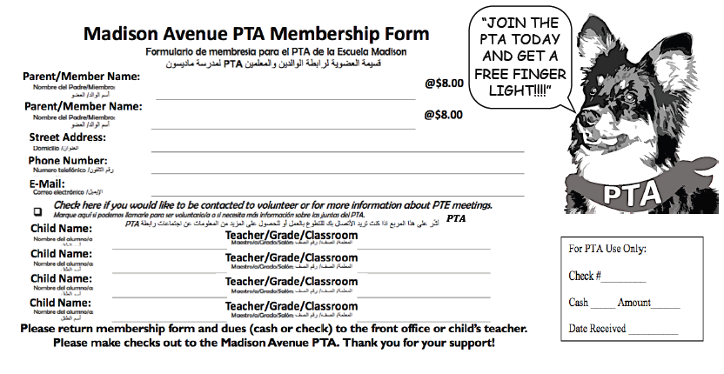
Join the Madison Avenue PTA* !!!!!
Membership pays for itself. PTA members receive “perks” throughout the school year! Get exclusive deals on school T-shirts, sweatshirts, yearbooks, back to school night meals, discounts on admission to PTA sponsored events (some events are even free for PTA members!), coupons for popcorn and school items at the PTA store, discounts at Lego Land, Office Max and much, much more! As a PTA member, you’ll save at least the cost of membership dues!

Parent Involvement has been proven to be the predictor of student success. By becoming a PTA member, you’ll be demonstrating to your child the importance you place on education. Please fill out the form below and return it along with your dues to the school. Dues are just $8 per person for the whole 2015-2016 school year.

It is the PTA who sponsors, raises funds, runs and/or assists in the many activities throughout the year at Madison! Because of the support of the PTA, your children and their teachers look forward to and enjoy events and activities such as:

- Father/Daughter Dance
- Mother/Son Night
- Talent Show
- Fifth Grade Activities
- Kindergarten & Fifth Grade Promotion
- Teachers' Appreciation Luncheon
- Drug Awareness/Red Ribbon Week
- Teachers' Breakfast
- Jog-A-thon
- 21st Century Learning Funding

- Bike Rodeo/Bike Safety
- School Assemblies
- Safety ID/Stranger Awareness
- Safety Patrol/Crossing Guards
- PTA Store
- School box top collection
- Candy sales
- Popcorn Cart
- Game Night

- Busing for Field Trips
- Back to School Night
- Kindergarten Orientation
- Spring & Fall Book Fairs
- Muffins & Moms
- Donuts & Dads
- T-shirts & Sweat Shirts sales
- School pictures
- Year Book
- Lunch on the Lawn

Did you know?

Just joining the PTA shows your child you care about school!

Please return membership form and dues (cash or check) to the front office or child’s teacher. Please make checks out to the Madison Avenue PTA. Thank you for your support!

PTA

Madison Avenue PTA Membership Form

Parent/Member Name:

Parent/Member Name:

Street Address:

E-Mail:

Phone Number:

@$8.00

@$8.00

Child Name:

Child Name:

Child Name:

Child Name:

Teacher/Grade/Classroom

Teacher/Grade/Classroom

Teacher/Grade/Classroom

Teacher/Grade/Classroom
Becoming a PTA Member does not mean you have to attend the meetings. Although the board and active members would love to see you at the association meetings, it is not required as a member. Please join and support your school.

----------------------------------------------------------------------------------------------------------------------------------------------------------

Please check payment type: Check Cash Total amount $_______________

* PTA = Parent Teacher Association

JOIN THE PTA TODAY!!

